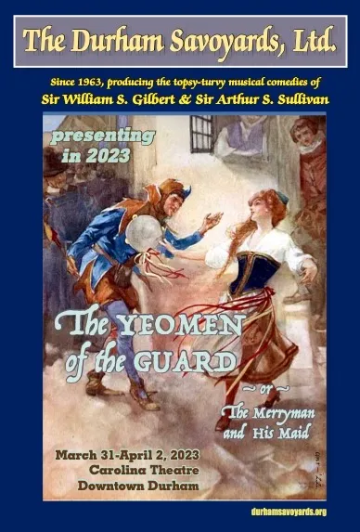
The Durham Savoyards, Ltd. invite you to advertise or become a sponsor of their 2023 presentation of Gilbert & Sullivan’s The Yeomen of the Guard

With an anticipated audience of over a thousand
Triangle-area music and theatre lovers, our playbill ads and sponsorships make great opportunities to spread the word about your business!
Playbill Advertisements (B & W)
Business Card | 2 1/8” x 3 ½“ | $100
1/4 page | 4 ½” x 2 ½” | $150
1/2 page | 4 ¼“ x 5 ½“ | $250
Full page | 8 ½” x 5 ½“ | $450

Sponsorship Levels
 | Level 1 | Level 2 | Level 3
Number of sponsorships available | 6 | 4 | 1
Printed ad in The Yeomen of the Guard playbill | 1/2 page | Full page | Full color ad inside front cover
Sponsorship acknowledgement in social media, digital, and printed promotional materials for The Yeomen of the Guard | √ | √ | √
Tickets to The Yeomen of the Guard at Carolina Theatre | 2 | 4 | 8
Vocal recognition from stage before each show |  | √ | √
VIP Cast and Crew Meet and Greet (VIP access to opening night party) |  | √ | √
Opportunity to set up promotional table in lobby during The Yeomen of the Guard |  |  | √
Minimum Investment | $700 | $1,500 | $2,500
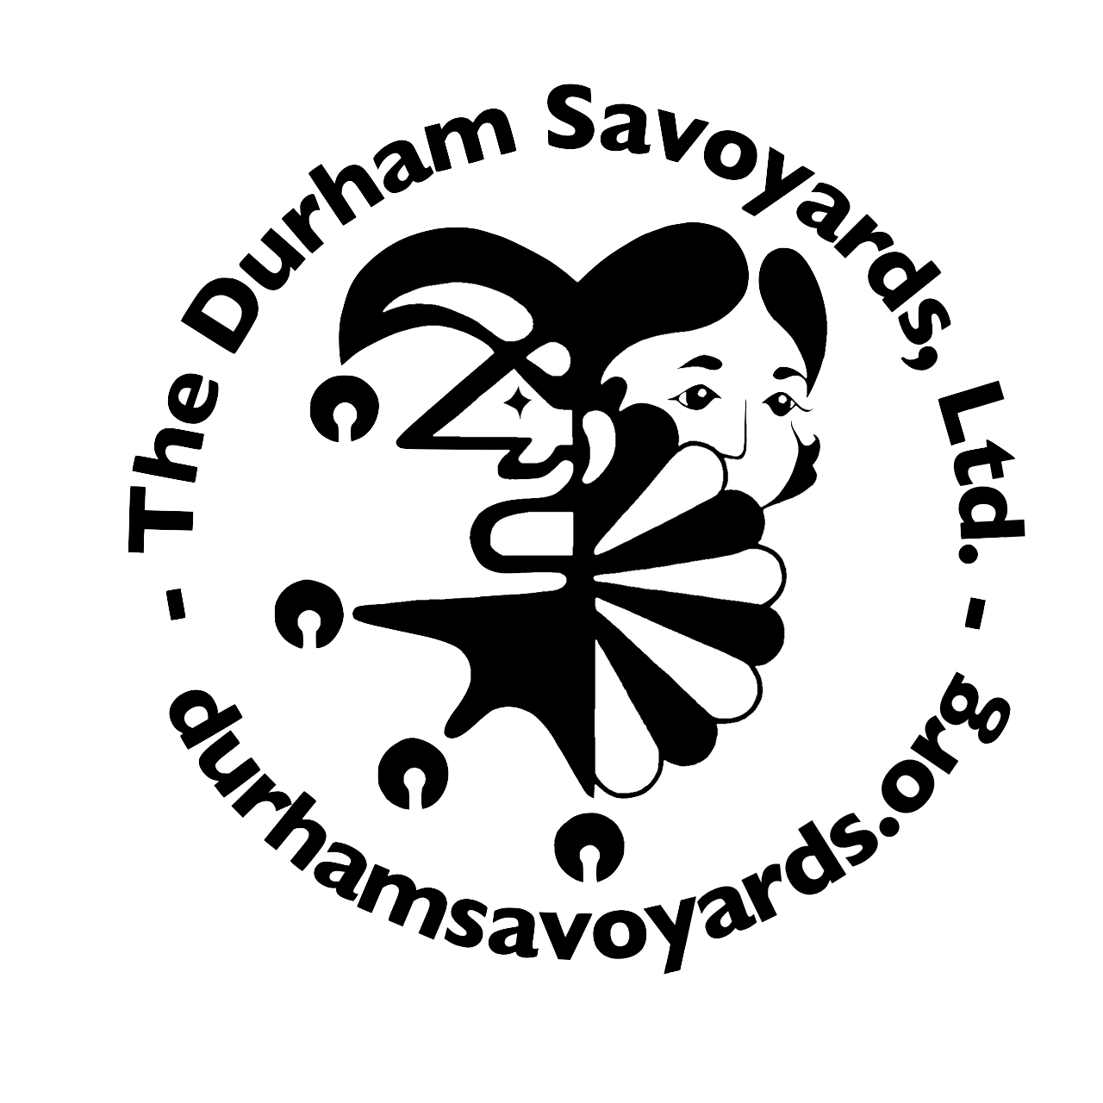
The Durham Savoyards, Ltd.
120 Morris St., Durham, NC 27701-3230

Your sponsorship allows us to continue our 60-year tradition of presenting high quality musical theatre.

The Durham Savoyards, Ltd. will:
- Produce a quality print program for distribution at our Gilbert & Sullivan operetta performances on March 31-April 2, 2023. All interior show program ads are black and white, except for interior front and rear cover.
- As soon as it is received, place an image of the ad on the Sponsors page of our website https://durhamsavoyards.org/backstage/sponsors/

Our Sponsors will:
- Supply the ad art in the file, orientation, and resolution formats required by the Durham Savoyards program designer. The Durham Savoyards cannot design or cover costs of ad art; however, a third-party designer can be recommended.
- Pay for the selected ad within 15 days of placing the ad request. Payment is requested by card or check payable to the Durham Savoyards, Ltd., 120 Morris St., Durham, NC 27701-3230.

Deadline for camera-ready artwork for ad: February 21, 2023:
New art must be submitted with correct proportions at 300 DPI, grayscale, and as a PDF, TIFF, JPG or EPS with all fonts embedded and/or outlined. Hard-copy business card counts as camera-ready.
Please contact us to ensure available playbill space if you are interested in a Level 3 sponsorship.
Send all questions to business@durhamsavoyards.org
Name ______________________
Business Name ______________________
Phone_____________________ Email_________________________________________________
Address __________________________
City _______________________________State______Zip___________
Ad Size: Business card Quarter page Half page Full page
- I have enclosed a check payable to Durham Savoyards, Ltd. for $_______
- Please charge $______________ to my □ VISA □ MasterCard
Name on card_______________________________________________________
Credit Card number______________________________________________________
Exp. Date ________________ CVV Code (code on back of card) _______________

Signature ________

